A Guide to Good Shepherd Hospital
Hello and welcome to Good Shepherd! Here’s a guide to help you during your time here. Hopefully it will give you an insight as to what goes on here, when and where so you can decide what it is you want to do here. My advice would be do and see as much as you can. So here’s what we managed to do in our 6 week elective here:
The House
The house is good and functional. There is a lady who will come in a do the cleaning and wash clothes for 100 E a week. The shower has character- to get the right temp turn the left hand tap fully on and then the right hand one (cold tap) on a fraction to get the right temp- it is very sensitive so you will have to work out the exact fraction! Also please be nice to the tortoise shell cat that often comes around- we have named her Mambo.
Food
The canteen food is good and great to try the everyday Swazi meals. Some of the previous students have stuck longer at it than others- great food but a bit repetitive after a while. Definitely worth a try, especially at the beginning while sorting out where to buy food.
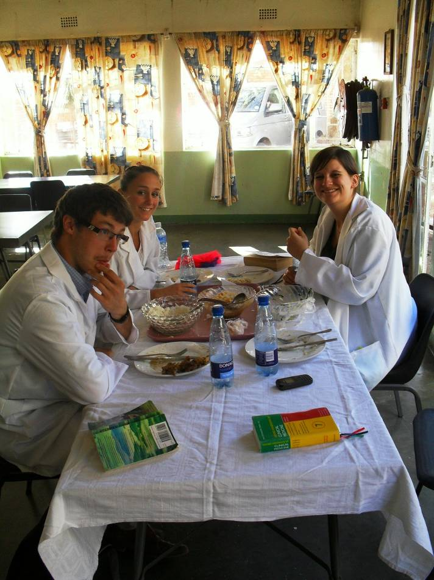
Lunch in the canteen

Town
To get there: You can get a Kombi into town that leaves from just outside the good shepherd gates and cost 4 rand into to town. Last bus around 5/6. On your return the bus leaves just under the big billboard with Good shepherd written on it. Otherwise it’s about a 35 minute walk in. We met a nice trustworthy guy called Terrance who is a taxi driver and will take you to and fro for 20E ; give him a call when you need a lift on 76037385
There are loads of shops to all your grocery needs- I would advise going into the market, which is in the middle of the bus station for vegetables, the supermarket under the FNB bank for freshly baked bread and Shoprite for all your other needs.
The only bar/restaurant we went to in Siteki was R&B. They are very friendly and no doubt you’ll make some friends in there if you go often enough. They serve surprisingly good chicken and calamari dishes.
The bank needed for international cards is the FNB next to the bus station.
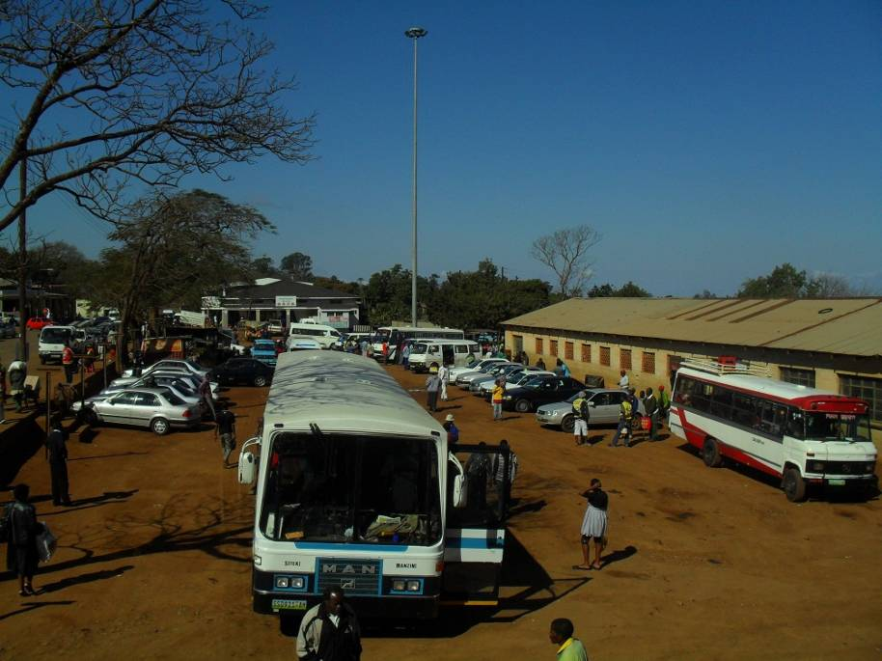
Siteki bus station and vegetable market on the right.
Mabuda Farm
This is where Doctor Pons and his family lives, they have a bed and breakfast there and a working farm. We strongly suggest going for a walk around the farm, it really is beautiful. One nice walk is going down to “the rocks” (ask Dr Pons the way) go past the run-way (that’s right Dr Pons has his own plane!). Try and get down to the rocks before sunset for an amazing view. We have had really nice evenings down there having a beer while watching the sunset, a perfect way to wind down after a day in the hospital.
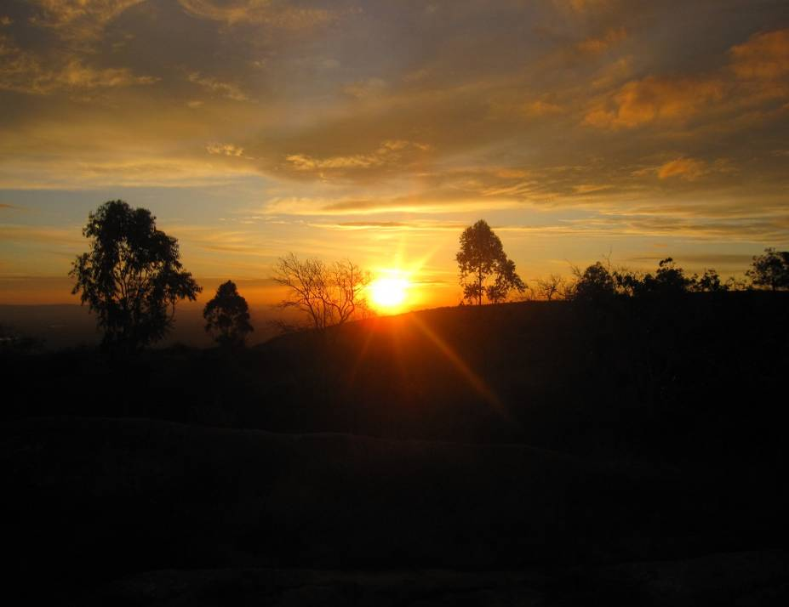
Sunset view at the rocks at Mabuda farm

Other good walk- turn right out the hospital and up the hill until you get to the top of the hill then turn right into the “nature reserve”. If you persist through the long grass you get to an amazing rock outcrop with an even more spectacular view.

Hospital
I would advise getting up early in the morning and getting the most out of the morning as everything seems to finish in the afternoon around 3/4ish. Also cold/rainy weather means fewer patients. Doctors meeting start 8-8.15 Monday Wednesday and Friday. Sometimes they happen and sometimes not. When they are on they are generally pretty interesting to get an overview of what goes on in the hospital. Also good to go if you a new so you can introduce yourself to all the doctors.
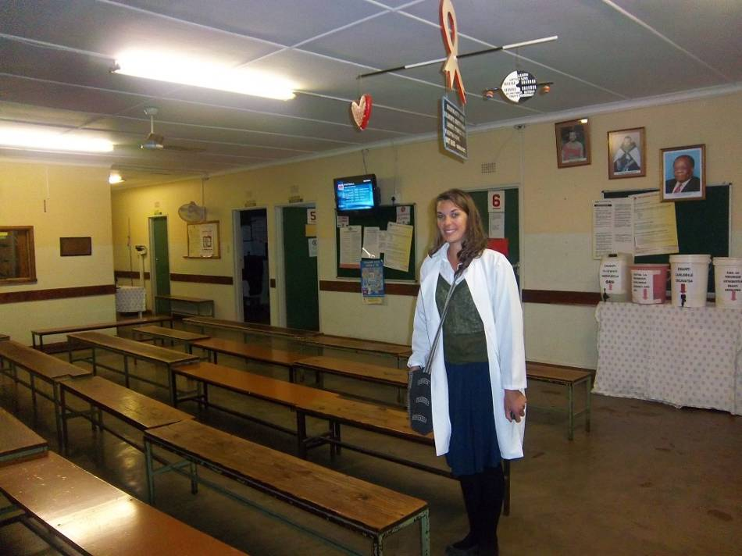
OPD at the end of the day- no patients!
You will need to get white coats from the laundry department on your fist morning- you can then change them later for clean ones. Apparently, according to the laundry women, you will not get a Swazi wife/husband if you have dirty coat!
Information about the doctors we have worked with:
Dr Koshy- works mainly in outpatients department starting around 9 and is very keen to get students involved. He will have you seeing your own patients while working alongside him as well as doing various clinical skills. Very willing to teach and seems to enjoy having and teaching students.
Dr Mamvura – Ward rounds on male ward which starts at 8.30. He is very keen to teach and discuss patient’s cases. I have learnt many valuable things being on the ward rounds.
Dr Joyce- works in the paediatric ward and does a ward round 8.30 everyday. She is a brilliant doctor and happy for students to come along with her ward round. She offers a “problem based learning” approach to teaching. She will expect you to do some reading and is very encouraging for you to learn.
Dr Atosha- Works in the ARV clinic. Monday and Tuesday are the busiest days there and worth a visit. She will probably get you to read the HIV guidelines for Swaziland. After doing this the management of HIV becomes a lot clearer. She is very keen to teach and is extremely welcoming to students. I have had a great time working with her; she encourages students to examine patients and may allow you to see your own patients.
Dr Pons- Eye clinic runs from Wednesday to Friday. Starting with the out patients clinic on Wednesday 9am where patients who need surgery will be admitted and receive it the next day. On Friday the follow up clinic sees all the patients who were operated on the previous day. It is a very worthwhile clinic to attend and best to do it all in one block to get the most out of it. Dr Pons is extremely keen to teach both theory and practical skills. He even has aims and objectives for you to achieve while doing the three day placement, if possible do some reading before to get the most out of it.
Dr Tefari- Does a surgical ward round around the whole hospital at 8.30 am, this then leads on to surgery from the rest of the morning and afternoon. He is also very welcoming to students and has let students scrub up and assist in surgeries.
Home based Care- This is an early start but well worth it; you need to be down there for 8am. Home based care go out into the rural community around Siteki and provide health care and food for those who are either house bound or who cannot afford the cost of getting to hospital. It is a truly amazing service. It probably one of the best days, they can only take one student at a time and best to ask them the day before if you can come along. They go out to all the rural homesteads and no doubt you will see interesting medicine and get to know Swaziland’s culture a bit better.
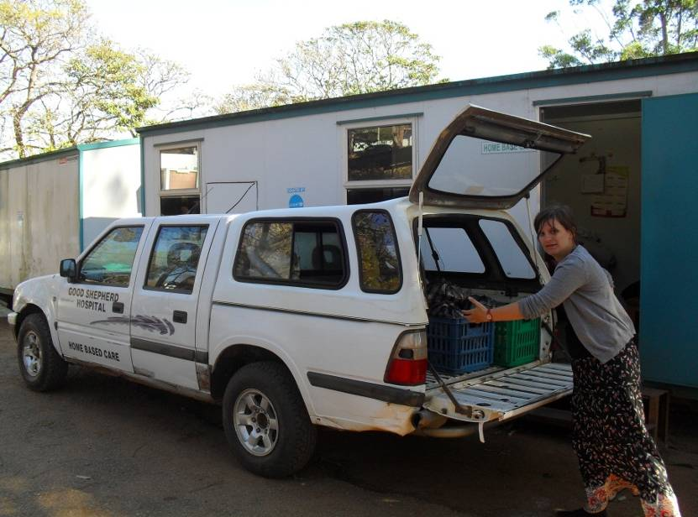
Home based care van outside the office
Maggie: A Rural health Promoter- Maggie is a really amazing woman. Her job is to go make sure people in the rural community stay in touch with the hospital either by helping them come into hospital or by putting them in touch with home based care. She is a really inspiring woman and spends most days trekking across the hills around where she lives in order to look after her community. She often attends the ARV clinic with patients that needed help getting into hospital. You should defiantly arrange to go out with her for a day. She will show you where she lives and show you some people that are unwell. She understands our position as medical students- we cannot prescribe medication. Regardless of this she will sometimes she will want you to go see a sick person to tell them to go to hospital or not (apparently it has more power coming from us rather than her!).
The other thing I organised with her was a day teaching people in the community about HIV and sex education. Maggie organised the venue and people, we organised the lesson. It was an amazing day and I strongly encourage other students to do it, not only because it is really great day, rewarding and interesting, but also because the people in the community said they wanted more lesson about HIV.
Just a word of warning- the day will involve long walks when you go out with Maggie so be prepared. Also she will expect you to pay for you own and her bus fare- which is only fair as she has little money and she will comes and collects you from the bus station in town and takes you to where she lives. So if you are interested in meeting her (please do!) ring her on: 76640704. – she told me to give her number out for other students to contact her.
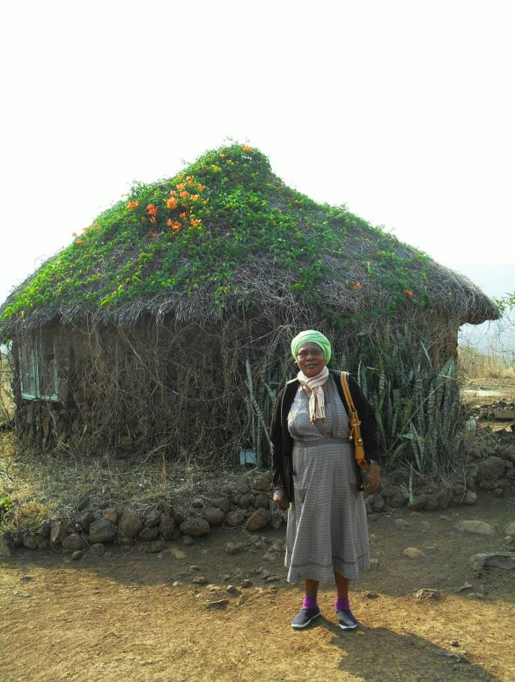
Maggie at her house.
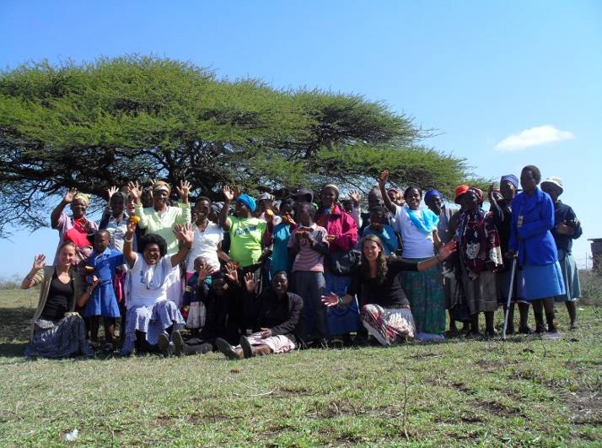
Our day out in the rural community teaching about HIV.

Umbombo Sugar Plantation in Big Bend
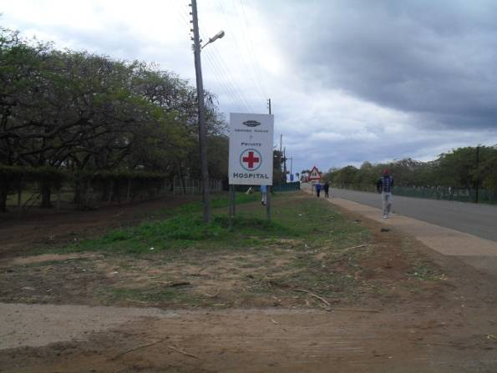

We spent 2 days over in Big Bend to see the private hospital there that is run by the Ubombo Sugar Estate. It is well worth the trip and amazing to see how the hospital there is run. There were only 2 doctors who worked there and they did EVERYTHING, from psychiatric assessments to performing C-sections. Unfortunately we didn’t see this when we were there but defiantly worth a trip, only 40 minutes away on the bus from Siteki. We stayed with a doctor who runs the hospital. Unfortunately he has now left Swaziland however his predecessor is willing to take on his role with the students too. He gave us his number to leave and he is very keen for other students to come and visit. So get in touch with Dr Pons who will guide you in the right direction. Also there are perks to going over there; the estate has its own game reserve so can go on a free safari if the hospital is a bit quite one afternoon. Also there’s a nice country club that’s good for a drink, game of squash or round of golf if it takes your fancy.

